


Marinka
Metanova
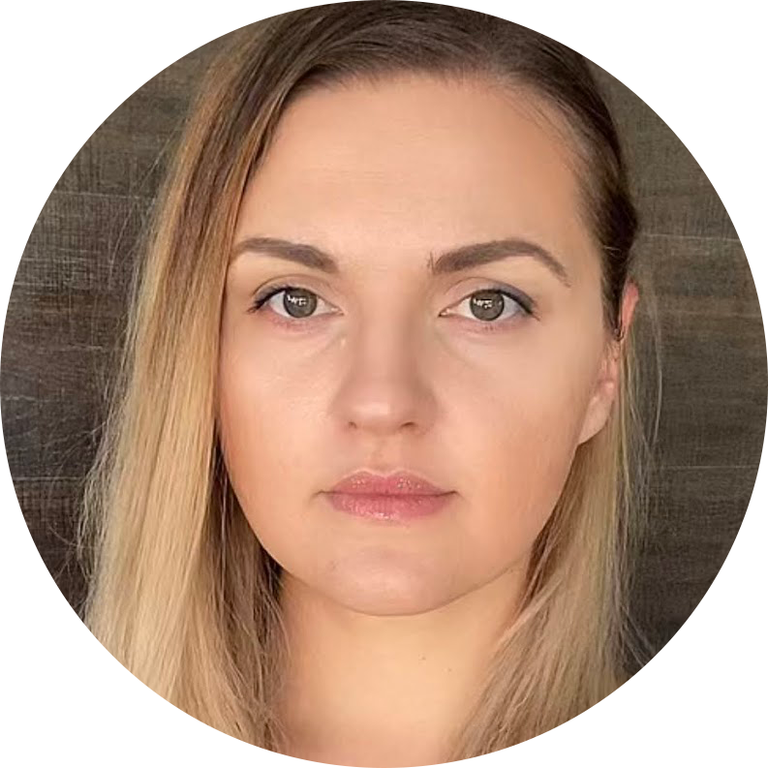 |  | Marinka  Metanova

Experience
Jul 2013–Mar 2015
Web designer • Viscomp
Development, redesign, coding (HTML, CSS and JS/jQuery) sites mobile version. Responsive design. Photo processing.
Mar 2015–Mar 2016
Frontend Developer • BG Marketing 2010
Production, modification and maintenance of websites and UI. Write clean HTML, CSS and JS/jQuery code. Experience in building responsive design, PSD to HTML. Using Smarty template.
Mar 2016–Nov 2019
Frontend Developer • Eurocoders
Develop new functionalities and maintain the existing ones in multiple projects. Strong experience in HTML, CSS(incl. SASS), JS/jQuery, Bootstrap 3/4, Cross-browser web applications. Test runner Gulp/Grunt. Work experience with WordPress. Skills in Photoshop, Adobe XD, InVision. Client-side experience, web performance, and network optimization. Experience with source control systems like Git and SVN.
Nov 2019
Frontend Developer • Freelance

Education
Plovdiv University, Plovdiv, Bulgaria
- Business Informational Technologies, Bachelor
Software University, Bulgaria
- Programming Basics – Feb 2021
- Programming Fundamentals with JS – Sept 2021
- JS Advanced & JS Applications – Jan 2022
- JS Back-End & ReactJS – May 2022

Main Skils
- HTML
- CSS – SASS
- JavaScript
- ReactJS
- jQuery
- Adobe Photoshop/Figma/InVision/Adobe XD
- Bootstrap/Responsive Design
- WordPress
- UI/UX

Communication
- Team-playing attitude
- Open for new skills
- Highly motivated
- Searching for new opportunities

Hobbies
- Photography
- Cooking
- Blogging
- Gardening
- Pet friends

Bulgaria
Plovdiv
+359 898 968 100
metanovamarina@gmail.com
metanov.eu

